2008 CALCULUS AB EXAM
Section II, Part A
Time – 45 minutes
Number of problems – 3

A graphing calculator is required for some problems or parts of problems.

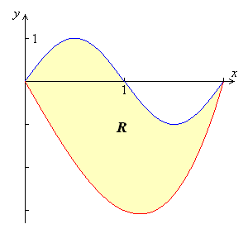

- Let R be the region bounded by the graphs of and , as shown in the figure above.

  - Find the area of R.

  - The horizontal line y = -2 splits the region R into two parts. Write, but do not evaluate, an integral expression for the area of the part of R that is below this horizontal line.

  - The region R is the base of a solid. For this solid, each cross section perpendicular to the x-axis is a square. Find the volume of this solid.

  - The region R models the surface of a small pond. At all points in R at a distance x from the y-axis, the depth of the water is given by . Find the volume of water in the pond.

GO ON TO THE NEXT PAGE.
t (hours) | 0 | 1 | 3 | 4 | 7 | 8 | 9
(people) | 120 | 156 | 176 | 126 | 150 | 80 | 0

- Concert tickets went on sale at noon (t = 0) and were sold out within 9 hours. The number of people waiting in line to purchase tickets at time t is modeled by a twice-differentiable function L for . Values of at various times t are shown in the table above.

  - Use the data in the table to estimate the rate at which the number of people waiting in line was changing at 5:30 P.M. (t = 5.5). Show the computations that lead to your answer. Indicate units of measure.

  - Use a trapezoidal sum with three subintervals to estimate the average number of people waiting in line during the first 4 hours that tickets were on sale.

  - For , what is the fewest number of times at which must equal 0? Give your reason for your answer.

  - The rate at which tickets were sold for is modeled by tickets per hour. Based on the model, how many tickets were sold by 3 P.M. (t = 3), to the nearest whole number?

- Oil is leaking from a pipeline on the surface of a lake and forms an oil slick whose volume increases at a constant rate of 2000 cubic centimeters per minute. The oil slick takes the form of a right circular cylinder with both its radius and height changing with time. (Note: The volume V of a right circular cylinder with radius r and height h is given by .)

  - At the instant when the radius of the oil slick is 100 centimeters and the height is 0.5 centimeter, the radius is increasing at the rate of 2.5 centimeters per minute. At this instant, what is the rate of change of the height of the oil slick with respect to time, in centimeters per minute?

  - A recovery device arrives on the scene and begins removing oil. The rate at which oil is removed is cubic centimeters per minute, where t is the time in minutes since the device began working. Oil continues to leak at the rate of 2000 cubic centimeters per minute. Find the time t when the oil slick reaches its maximum volume. Justify your answer.

  - By the time the recovery device began removing oil, 60,000 cubic centimeters of oil had already leaked. Write, but do not evaluate, an expression involving an integral that gives the volume of oil at the time found in part (b).

END OF PART A OF SECTION II

